

**AEROTECH INC.**

**USER MANUAL**

**WHERE THE SKY IS ONLY THE BEGINNING**

**TABLE OF CONTENTS**

1. Introduction

1.1. Purpose of the Application……………………………………………………………………….page 3

1.2. Key Features………………………………………………………………………………………..…..page 3

1.3. System Requirements……………………………………………………………………………….page 3

2. Getting Started

2.1. New Customer Registration……………………………………………………………………..page 4

2.2. Login Process……………………………………………………………………………………………page 5

3. Exploring the Application

3.1. Home Screen……………………………………………………………………………………………..page 5

3.2. Flight Search & Confirmation……..………………………………………………………………page 6

4. Managing Bookings

4.1. Modify Bookings & Flights…………………………………………………………………………..page 6

5. Frequently Asked Questions (FAQ)……………………………………………………………………………..page 8

6. Troubleshooting………………………………………………………………………………………………………….page 8

7. Contact Support………………………………………………………………………………………………………….page 9

**INTRODUCTION**

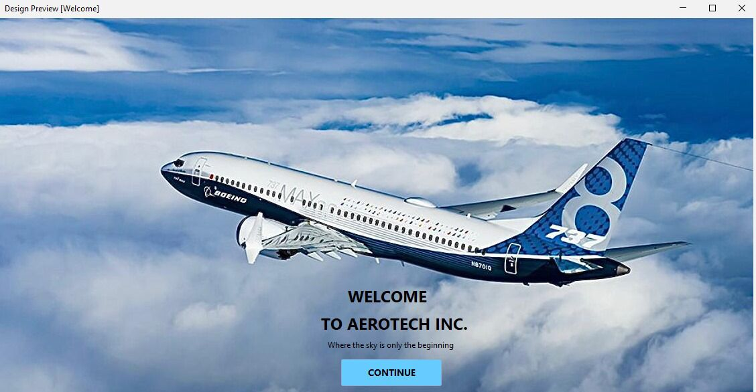

**1.1 Purpose of the Application**

The purpose of the AeroTech Inc. Flight Reservation System Application is to make it easier for travellers to book flights. With the help of this intuitive application, customers can book seats, look for flights, and pay for their trip plans. The programme seeks to streamline the booking procedure, saving time and energy for the user and the airline alike, all the while ensuring a smooth and effective experience for everyone concerned.

**1.2 Key Features**

The following are the main features that our Flight Reservation System Application provides:

**Flight Search:** Travellers may look for flights using a variety of parameters, including trip dates, travel class, and cities of departure and arrival.   
**Selecting a Seat:** Travellers are able to select the seat that best suits their needs throughout the journey, including additional legroom, window, or aisle seats.   
**Payment Options**: Credit cards, debit cards, and online payment services are among the payment methods that the application takes.   
**Traveller Information**: Users can enter information about their travelling companions, such as names, phone numbers, and any special needs.

**1.3 System Requirements**

The following system requirements must be met by users' devices in order for them to utilise the Flight Reservation System Application efficiently:

**Operating System:** Windows 11 and macOS High Sierra or later are compatible with this application.   
**Internet connection:** For smooth operation, a reliable internet connection with a minimum speed of 1 Mbps is needed.   
**Screen Resolution**: Screens with a resolution of 1024x768 pixels or above are recommended for optimal operation of the programme.

Users may guarantee a seamless and pleasurable flight reservation system application experience by adhering to these system requirements.

GETTING STARTED

**2.1. New Customer Registration**

New customers of AeroTech Inc. are required to register in order to be able to have full access to the services that we provide. After having registered, they are then allowed to login and reserve their flights.

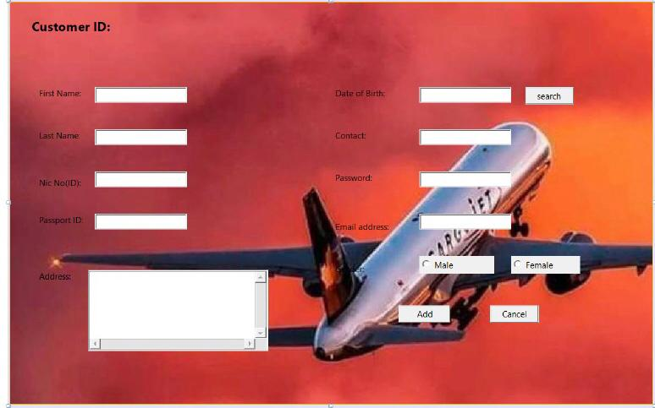

Above is our registration page. You are required to type in your details as requested. Note that all the details are needed.

For the Date of birth, you are to make use of “Search” which will allow you to choose your date of birth from a calendar provided.

Click Add to finalise your registration. Note that you will be provided with a customer ID after having completed your registration.

Click Cancel to quit.

**2.2 Login**

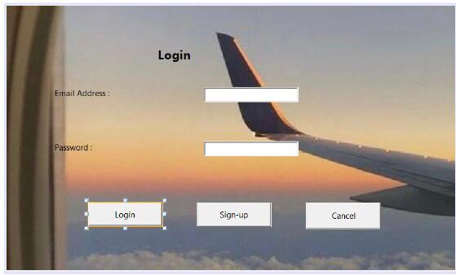

Above is the Login page. Here you are allowed to login using your email address and password you had created during registration.

If you try to login without prior registration, you will be referred to “Sign-up” where you will be redirected to the registration page.

Click Login to continue.

EXPLORING THE APPLICATION

3.1. Home Screen



This is the home screen. It has two buttons for you.

“Customer” is for registration and logging in

“Tickets” is for you to book flight tickets after having registered and logged in.

**3.2. Flight Search & Confirmation**

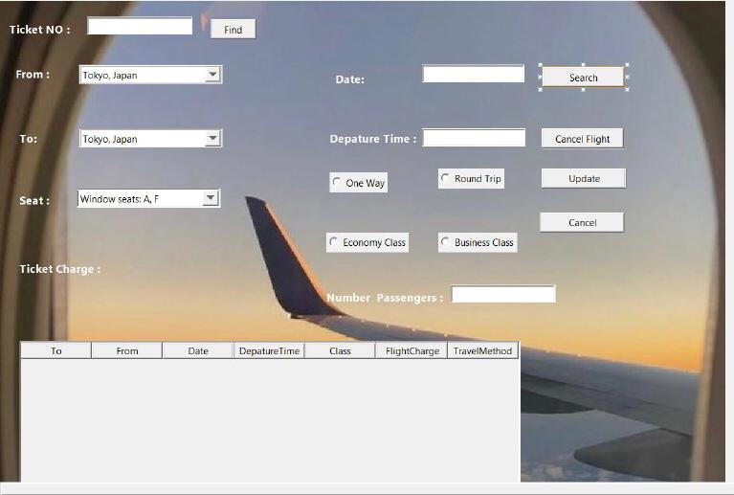

On this page, you will use your Ticket number to book flights available for you.

You need to choose the place of depature and your destination along with the date and time you desire.

You will choose between one way or round trips, economy or business class.

You will choose the seat(s) and add the number of passengers.

Available flights that fit your descriptions will be shown for you as well as the ticket charge.

**MANAGING FLIGHTS**

**4.1. Modify Bookings & Flights**

This section of the AeroTech Inc. application is reserved for employees.

Only staff can login and make changes with the flights

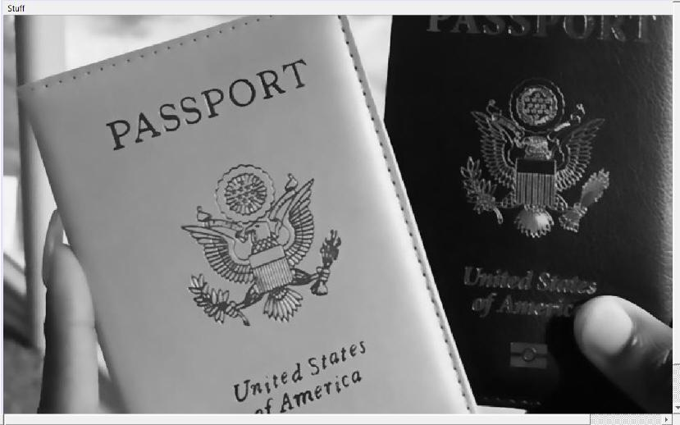

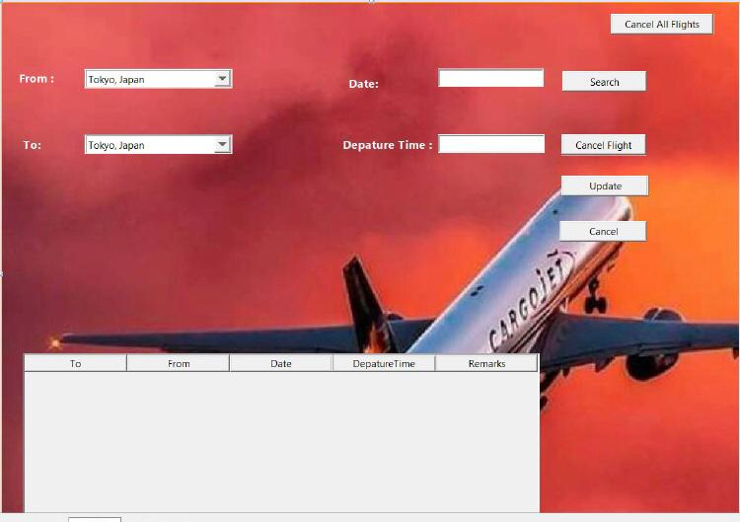

The staff can update the changes that apply to the flights as well as their availability.

Staff can also cancel all flights.

All this can be done while the staff members see and keep track of the changes made.

**FREQUENTLY ASKED QUESTIONS**

Here are some of the most frequently asked questions about the AeroTech Inc. flight reservation application

1. How can I use this programme to book a flight?   
Detailed instructions for scheduling flights, including how to choose your dates of travel, seats, and payment methods.

2. Can I modify or cancel my reservation?   
Details on how to change or cancel reservations, along with any costs or penalties involved.

3. How can I see how my reservation is progressing?   
Information on how to obtain airline schedules, seat assignments, and any special requests related to reservations.

4. Which forms of payment are accepted?   
a list of the payment options that the application accepts, such as online payment systems, debit cards, and credit cards.

**TROUBLE SHOOTING**

Here are some key points on troubleshooting the AeroTech Inc. Flight Reservation System application:

Handling wrong inputs:  
The system should be able to handle wrong inputs like wrong dates, times, passenger numbers etc. and deliver clear error messages to the user.

Handling booking errors:  
The system must be able to handle errors that may occur during the booking process, such as sold-out flights, system failures or incorrect passenger information. Proper error messages should be displayed for the user

Search Error Handling:  
The system should be able to handle errors that may occur during an immediate search, such as connection problems, system errors, or database errors. Clear error messages must be provided to the user.

Validation and Validation Errors:  
The system should be able to handle errors that may occur during the validation and validation process, such as email delivery problems or system errors. The user must be notified of such errors.

Detection of security breaches:  
The system should have appropriate access control and encryption mechanisms to prevent unauthorized access and detect security breaches such as SQL injection attacks.  
Compatibility testing:  
System compatibility should be tested using different browsers, devices and screen resolutions to ensure a smooth user experience on different platforms.  
Usability testing:  
The ability of the system to provide users with relevant and accurate information, as well as ease of navigation and handling of user input, should be tested.

**CONTACT SUPPORT**

For issues that you may encounter, or questions that you may have, please contact:

+27 61 614 5019

+27 71 479 0848